Project Report: Sport... Streaming Sports Videos

# COMS W4170: User Interface Design

# Group: 5

# Team: 1001 (5 + 4)

## Team Members

## 1’s: Laima Tazmin (lt2233@columbia.edu)

## Anwesha Deb (ad2773@columbia.edu)

## 0’s: Waseem Ilahi (wki2001@columbia.edu)

## Dongouk Moon (dm2615@columbia.edu)

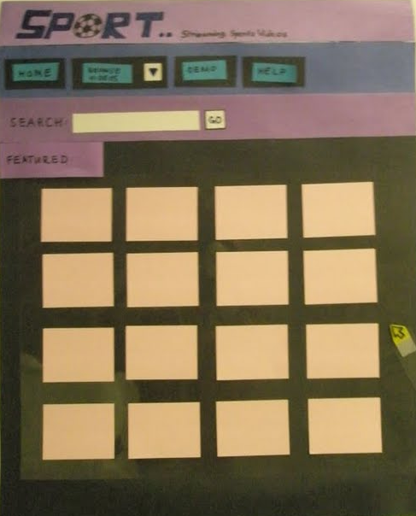

# PART 1

# I. Introduction and Initial Design

    Intro goes here………..

Following are the pictures of the team’s brain storming session and the work on the initial design for the prototype.

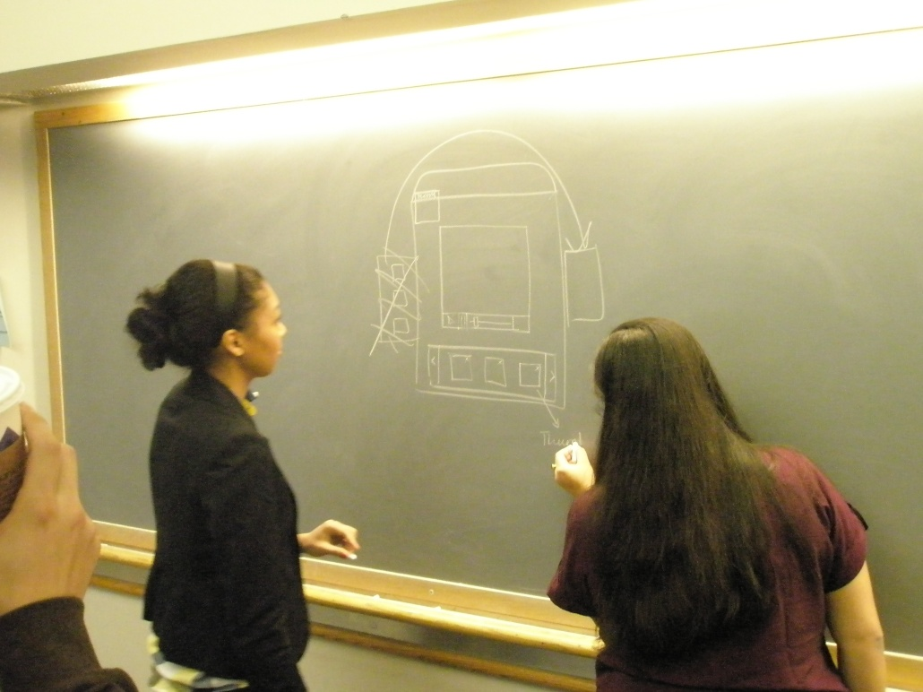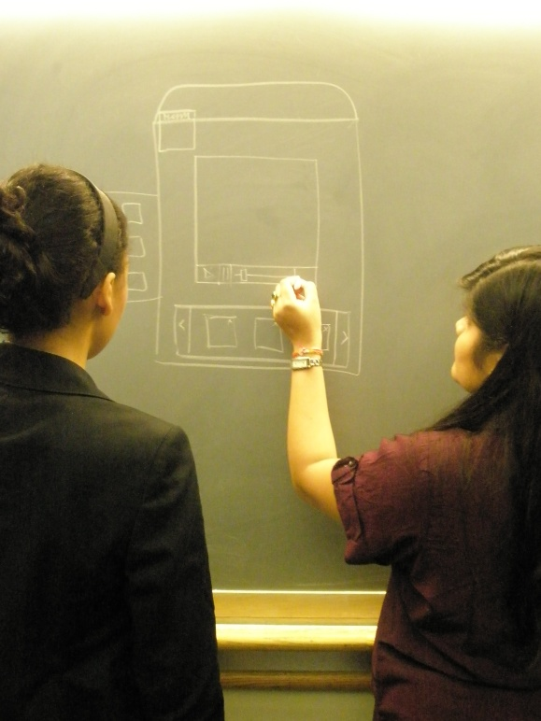

### 

### Personas and Use Scenarios:

1. Persona: John Smith

Ardent basketball fan – 35 – is a frequent visitor of ‘SPORT’. He likes to pick videos right away and watch them. He likes to make bets on teams with his friends.

**Use Scenario:** John opens up Sport…, and finds two games he is looking for in the ‘Featured’ list on the Homepage. He clicks on the ‘Add to playlist’ button for both to add the videos to the playlist. But he wants to watch another game which is not being featured, so he searches for it in the Search box and presses the ‘GO’ button. When the Search Results are displayed, he likes another two games and wants to watch them simultaneously. So he selects two more videos to add them to the playlist, and then clicks on the playlist arrow button, and then clicks on view all – to watch all 4 videos simultaneously. He then wants to watch one video in full screen – so he moves his mouse over his favored video and clicks on it to enlarge the selected video. He keeps shuffling between the 4 videos in the playlist.. He then realizes he does not want to watch one of the videos, so he wants to delete it from the playlist – so he goes to playlist and just presses the cross button on the video to delete it from the playlist – Then clicks ‘OK’ on the pop-up to confirm that he wants to delete it and keeps watching the rest of the videos.

1. Persona: Lauren Weinberger

17 year old – High School student – Loves to browse the net – Likes exploring new websites.

**Use Scenario:** Lauren stumbles onto the ‘SPORT’ site- and sees a lot of different sports videos being played simultaneously. She likes the idea, and wants to know more about the site, so she clicks on the ‘DEMO’ button on the menu bar. After watching the ‘DEMO’, she understands that the site allows you to create your own playlist and watch all of the videos in the playlist simultaneously. So she wants to try that out. She does not know what to see, so goes to ‘browse’ and selects – Tennis from the drop down menu. All videos related to ‘Tennis’ are then displayed. She uses the navigation button at the bottom of the screen to see more options. She then selects one video and wants to just see it in enlarged mode, so she wonders how to do that and as soon as she moves the mouse pointer over the video, a tooltip is displayed saying – ‘click to enlarge’. So she now knows how to enlarge and thus clicks on it. The enlarged video now starts playing. After a while, she just wants to check what the ‘help’ menu has, so she clicks on it and the ‘help’ contents are displayed. She clicks on the hyperlinks – and the corresponding contents are displayed. She’s satisfied with it and just goes back to the homepage by clicking on the homepage button.

### Storyboard for the Scenario 1:

1. From the home screen John clicks on the “add to playlist” button and adds two videos to the playlist. The system shows the dialog “video added to playlist” for both. The message goes away in 1 second.

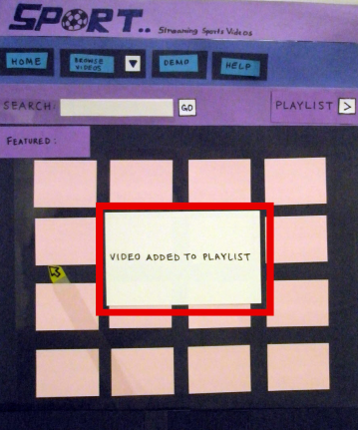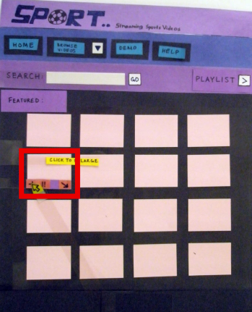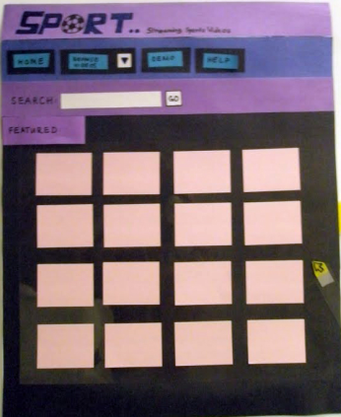

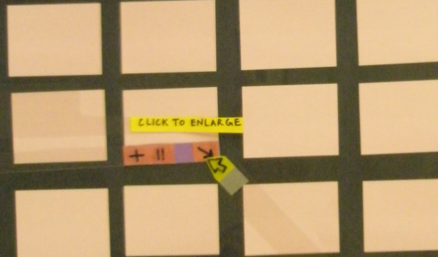

1. 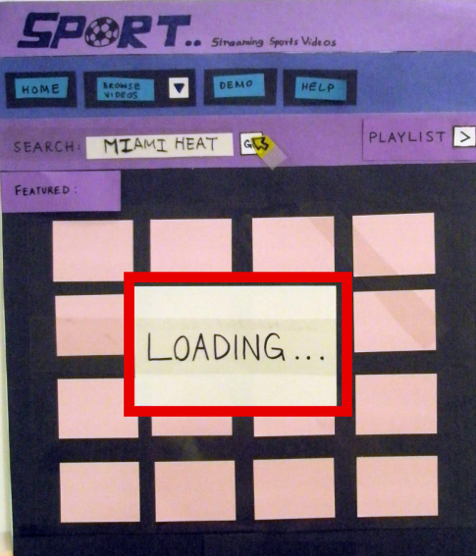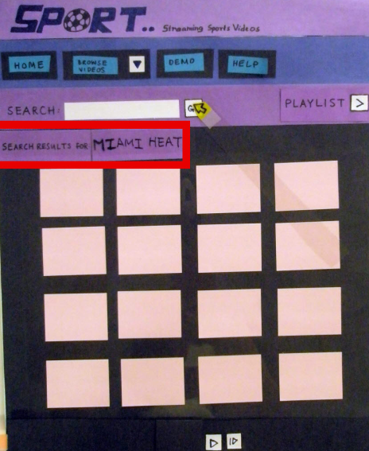John wants to search for a team, so he enters the team’s name in the search box and clicks go. The system shows loading and then shows him the results.

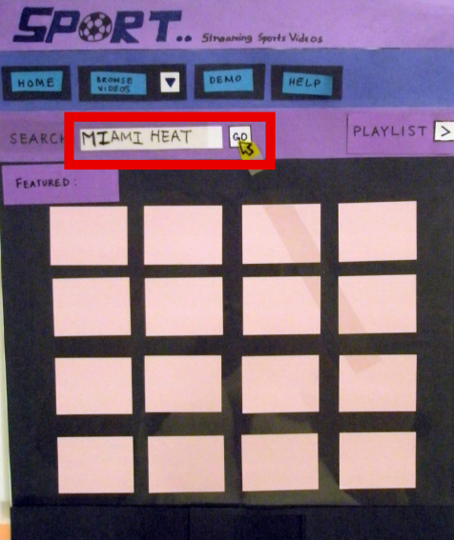

1. John now adds two videos to the playlist.

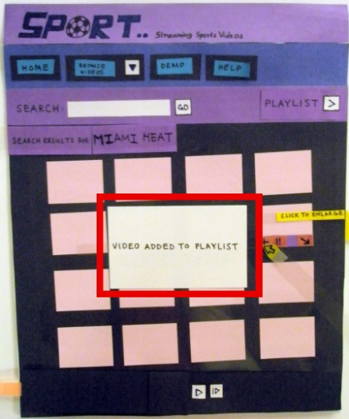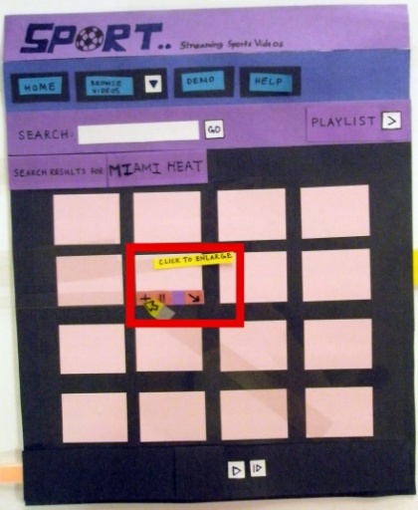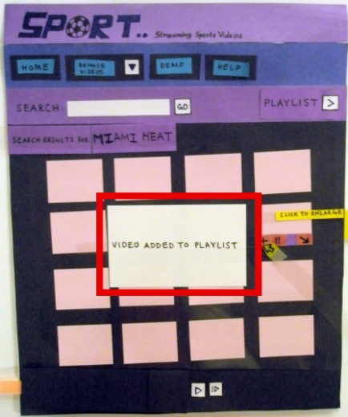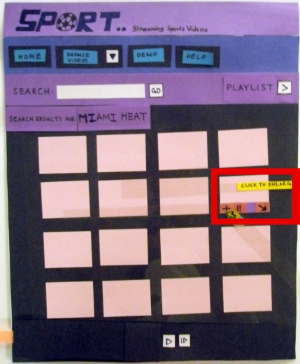

1. John opens the playlist and selects view all.

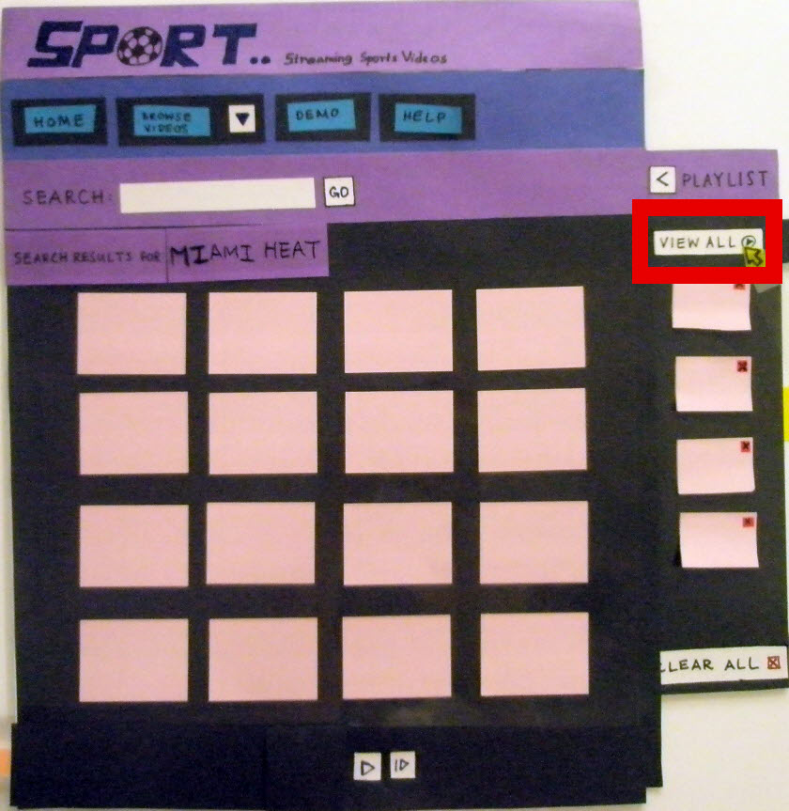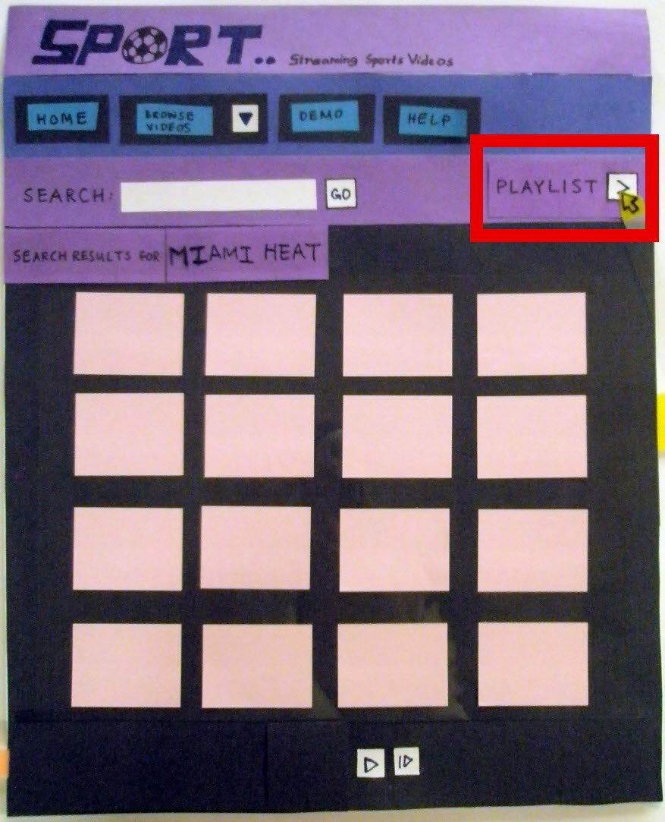

1. System “Loads” the videos, and the screen changes to show the playlist playing. John, then clicks on the video he likes to watch to enlarge it.

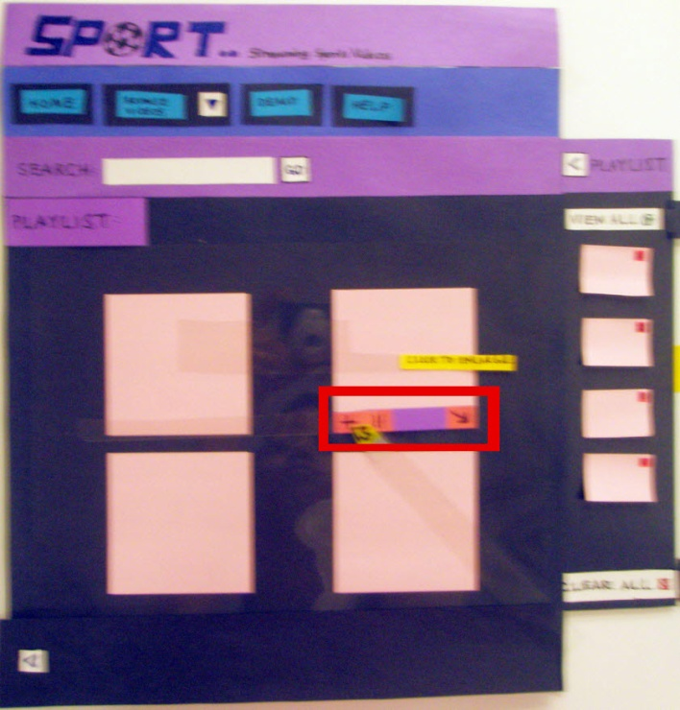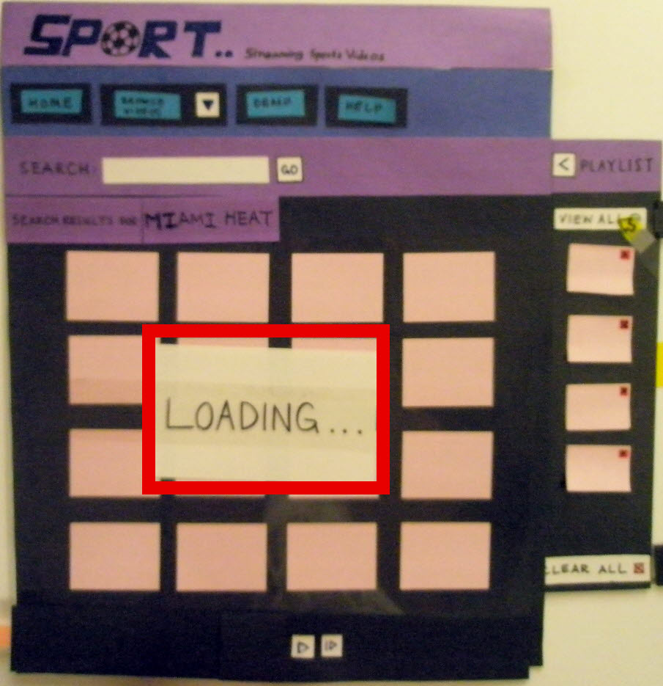

1. 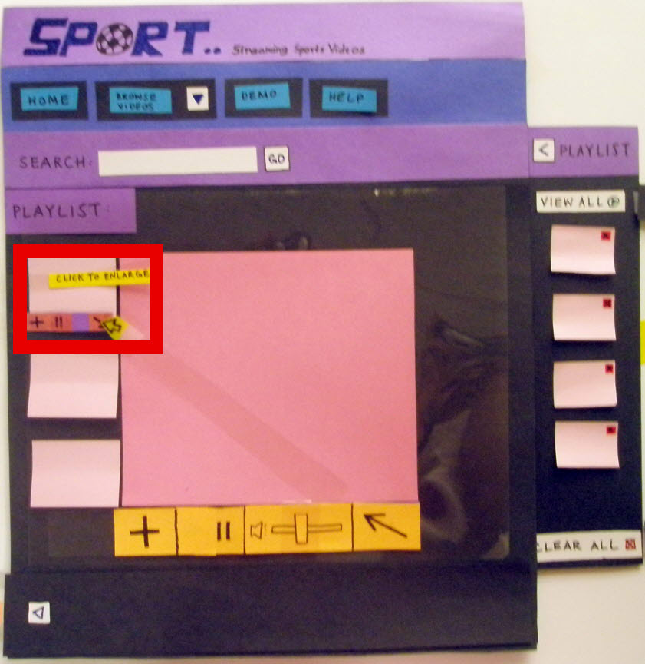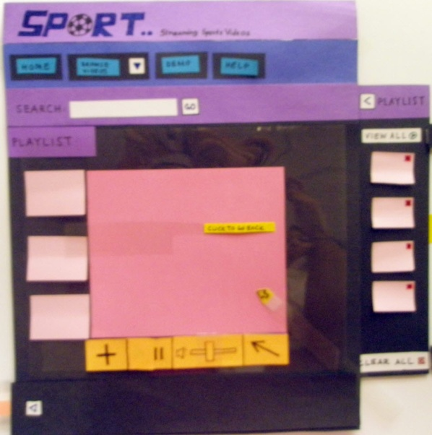While on the next screen, John clicks on a smaller image to enlarge that video and resize the enlarged one.
2. John then removes one of the videos from the playlist and continues watching the rest of them.

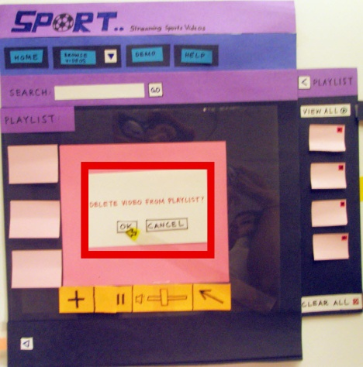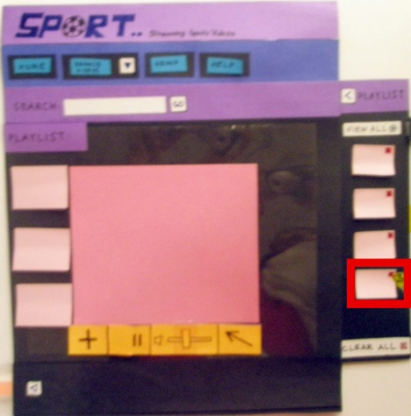

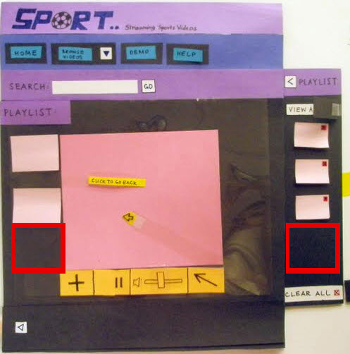

### Storyboard for the Scenario 2:

1. Lauren starts from the home screen. Looks at the demo button and clicks on it to go to the demo screen.

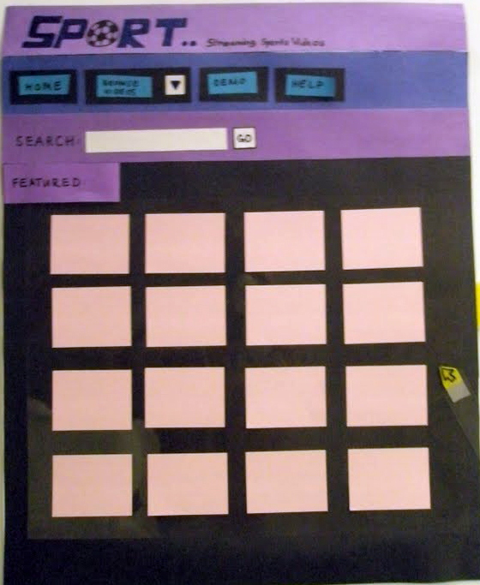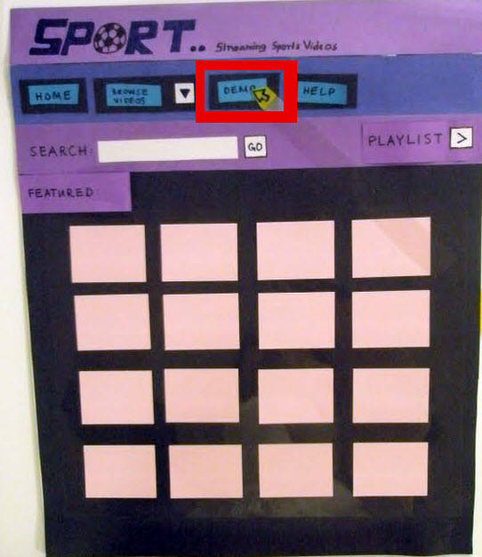

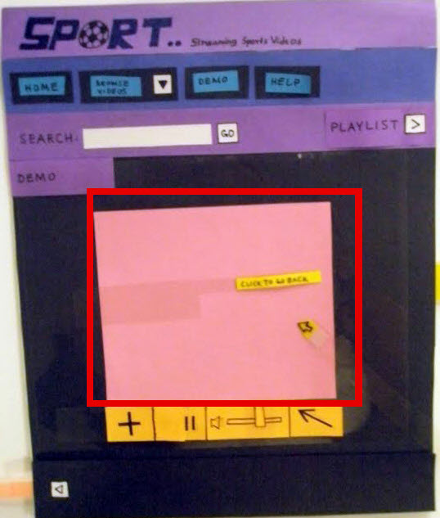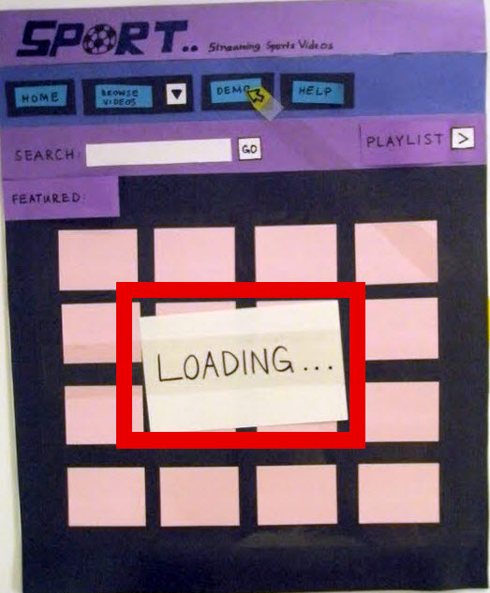

1. She starts with the browse button and choosing tennis videos from the browse menu.

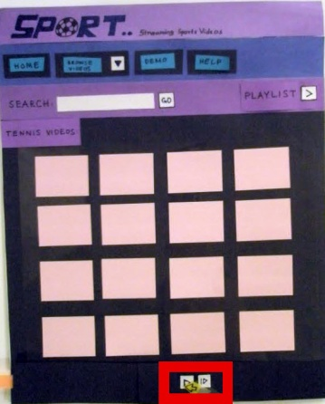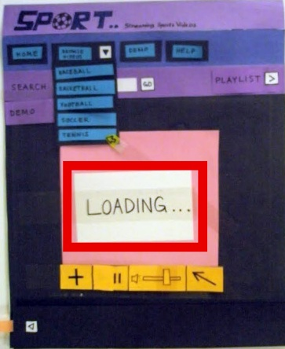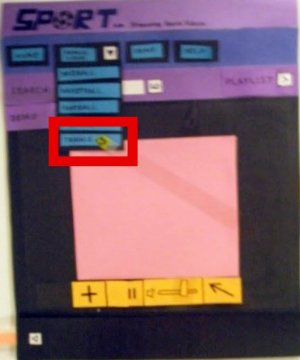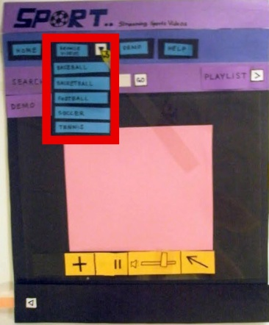

1. 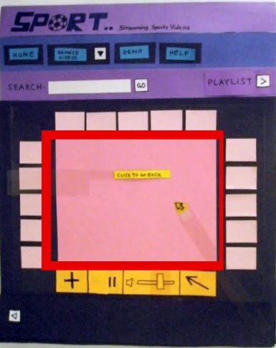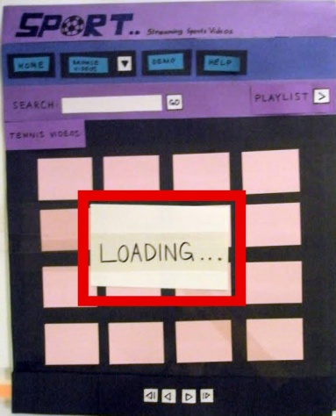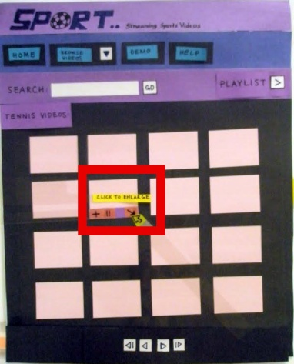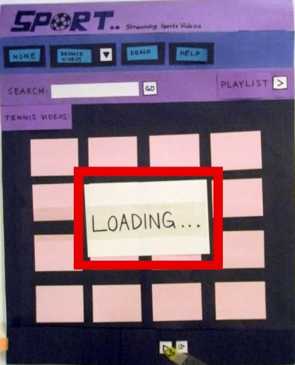While browsing through the tennis videos she likes one and clicks on it to view the enlarged video.
2. She changes the video by clicking on the small ones, and then she tries to check out the help menu.

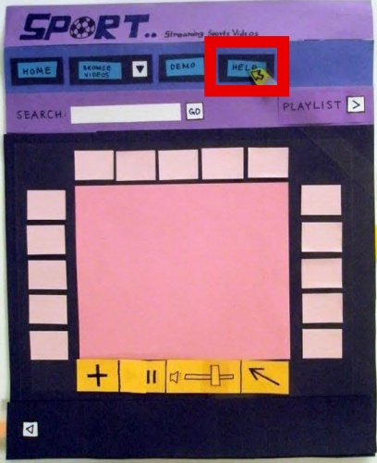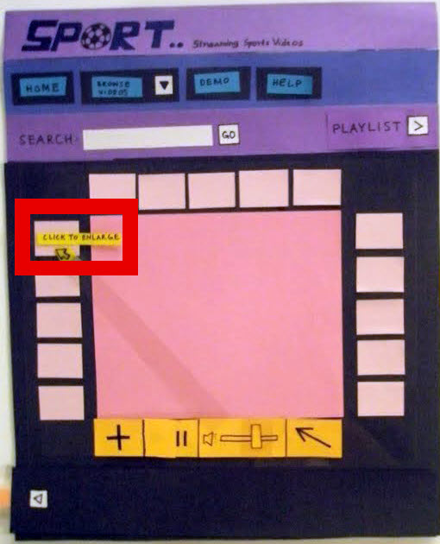

1. 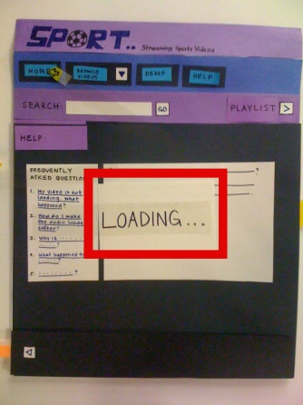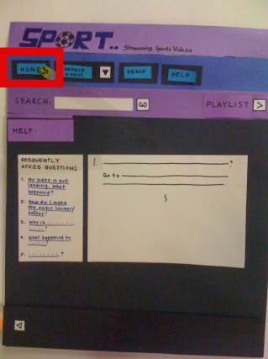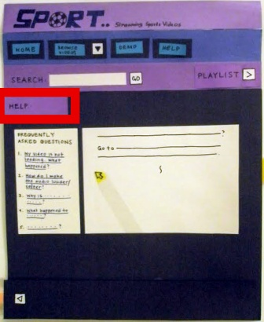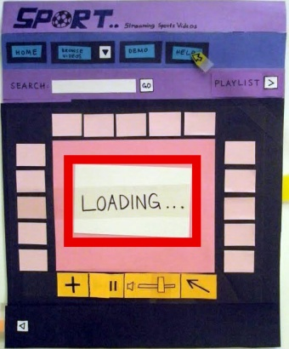She plays around with help screen, by selecting different help subjects/questions. Then she goes back to home screen.

# http://docs.google.com/File?id=dcjgvhr8_117gjh6bsd9_b

# PART 2

# III. Testing

     The test took place in the CS Lounge. All four users tried some same features and some different features. One was more concerned with the help screen. He is the one who discovered the “problem” of searching for the help. He typed something related to the help in the search box, which was still visible, but it gave an error. This pointed us to make sure we make changes to the search field.

Another user pointed out the minimize button present in the demo video and asked what will happen if I click on it. We need to change that feature too. Demo screen should not have the minimize button anywhere I the control bar.

The others were more concerned with the playlist. And extensively tested the playlist feature our system provides.

Following are some of the pictures of the index cards on which our observer took notes.

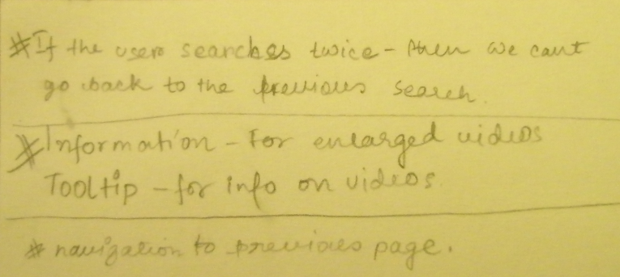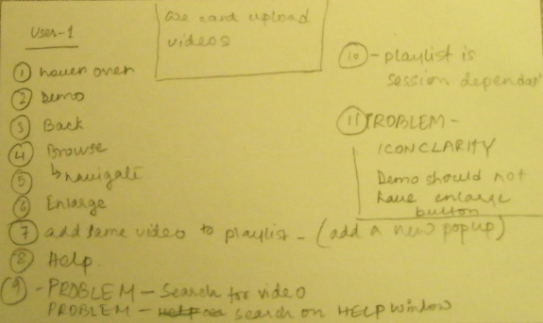

We are also going to include a few pictures of the users testing our prototype.

The problems found will be explained and then fixed in the sections to come.

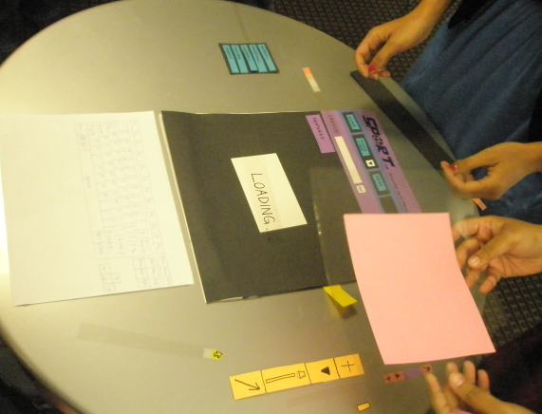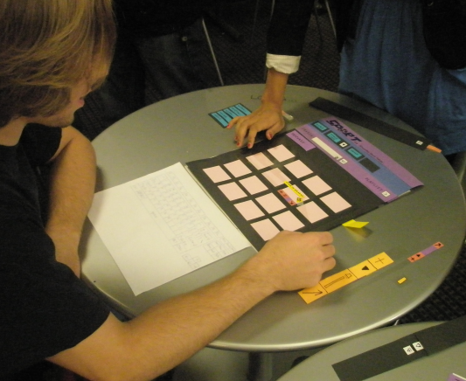

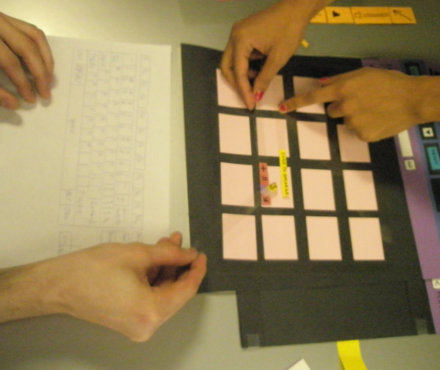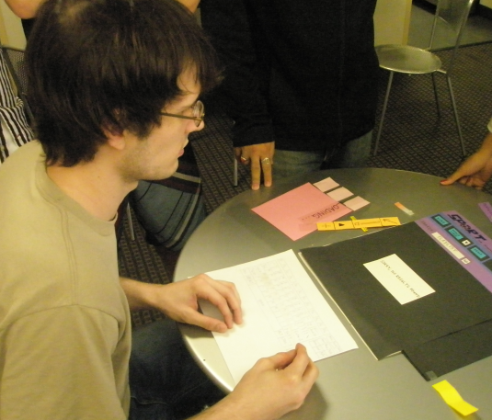

# C:\Users\Waseem Ilahi\Desktop\COMS 4170 (Assn - 2)\PA210694.JPG

# PART 3

# IV. Evaluation

## Visibility of System Status

Sport has a very horizontal UI. The entire task transition is quite visible. The user knows when he/she is in the system, all the times. However, there is requirement for explicitly showing system status for two kinds of tasks. First, when the user adds a video to the playlist and second is when transitioning from one major view to another, e.g., hitting go after typing in a search query for videos, shows a loading dialog box, that shows the system is retrieving videos for the user.(See figures 1(a) and 1(b) below).

##### 

##### Figure 1(a): Loading… Dialog Figure 1(b): Video Added Dialog

## Match between System and the Real World

Sport… uses very basic terminology, as it is a very simple system that presents the user with the videos of the five famous sports. The Menu has a very understandable layout and the names for each search result are self explanatory.

##### Figure 2: Realistic Menu Entries

## User Control and Freedom

Since, Sport... is a web based application, users can simply go back and forward, as they like. However, Sport… does provide internal navigation, especially for search results. Also, the user can simply click on the home menu button to go to the home page. Nevertheless, the navigation among the search results is provided by sport… Since, there is no user specified deletion, so there is no need for undo or redo. As mentioned before, Sport… has a pretty horizontal interface. There is no possibility of user getting lost in the depth of the system somewhere.

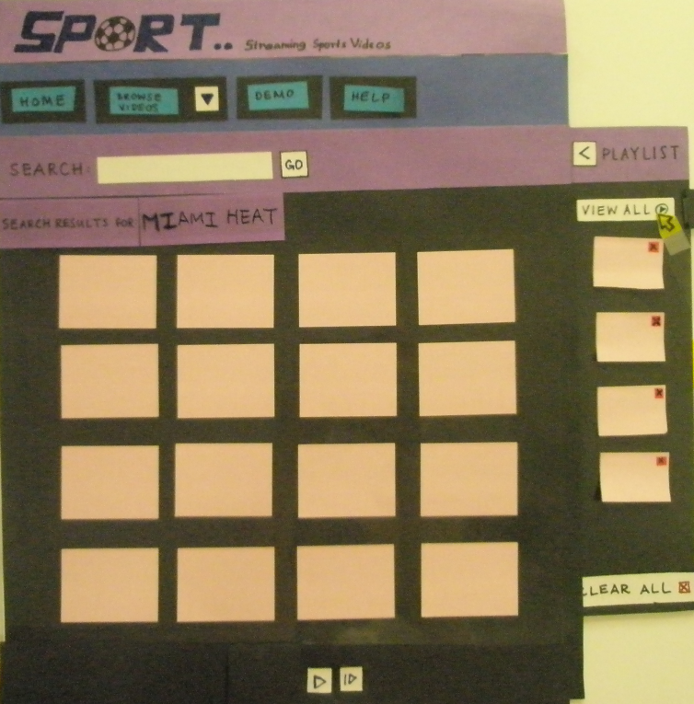

##### Figure 3: Easy navigation through the playlist and the main screen

# Consistency and Standards

The entire UI is pretty clear and there are no ambiguities as far as the main features are concerned. However, the testers did find an error with the search box. While on the help screen, there needs to be a search box for searching through the help menu. The users thought that the search box, we use to search for videos, was also for the help search. It was not originally in the UI design, so we are going to take measures to correct this problem. Figures 4(a) and 4(b) show the problem areas I the interface.

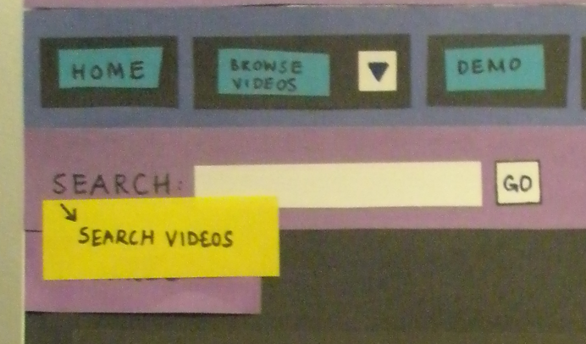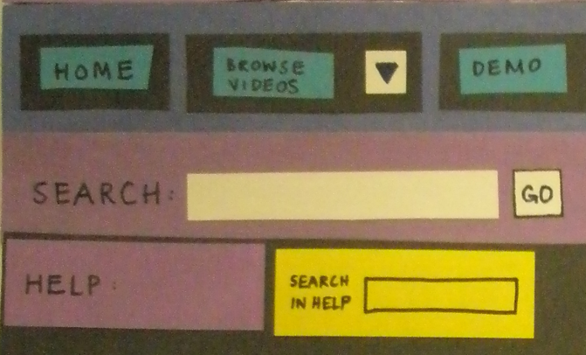

##### Figure 4(a): Change Search Heading Figure 4(b): Add Search box for Help

## Error Prevention

Sport… takes good measures to implement the error prevention. The only place where a user can commit error is when a user clears up the playlist by mistake or even deletes a video from the playlist. Sport… provides a check in the form of a popup dialog box that asks the user to confirm the action. Other than that, Sport… doesn’t provide the user any other opening s to commit errors.

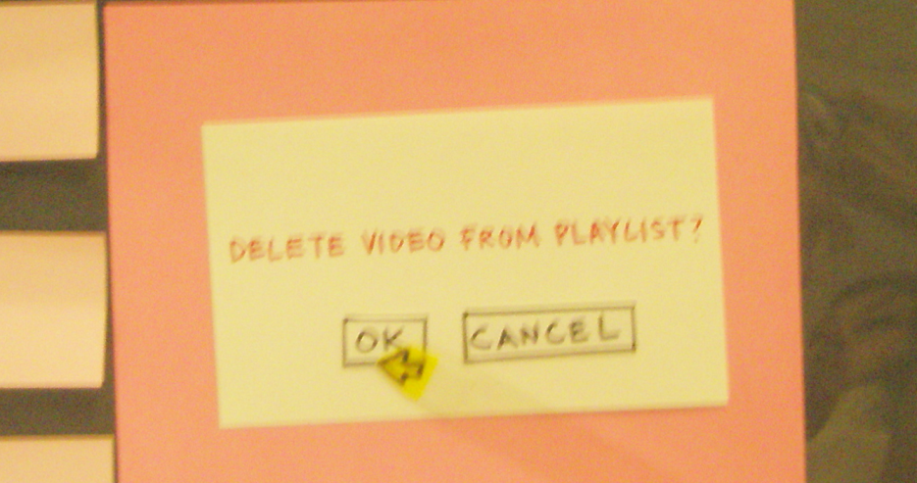

##### Figure 5: Confirmation Dialog Box to delete a Video from Playlist

## Recognition Rather than Recall

Again, because of its horizontal nature, the UI of Sport… doesn’t require its users to remember much. All they need to remember is what they want to see. This is also taken care of, in the playlist. The items (videos) that the user adds to the list are visible in the playlist as the thumbnails. Also the interface has appropriate labels for user to know where in the UI there are at that moment. Figure 6 shows the playlist (opened).

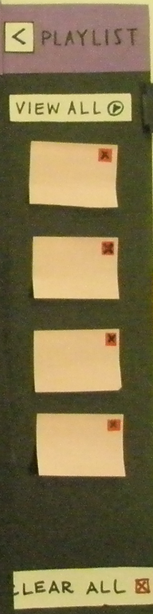

##### Figure 6: The playlist (opened)

## Flexibility and Efficiency of Use

While in the Enlarged video screen, the users have the choice to change to any other smaller videos on the same screen by clicking once on the small video they want to enlarge. A novice user, who hasn’t followed the demo provided with the system, will go back to the original screen and then click on the other video to see it, thus doing extra unnecessary steps.

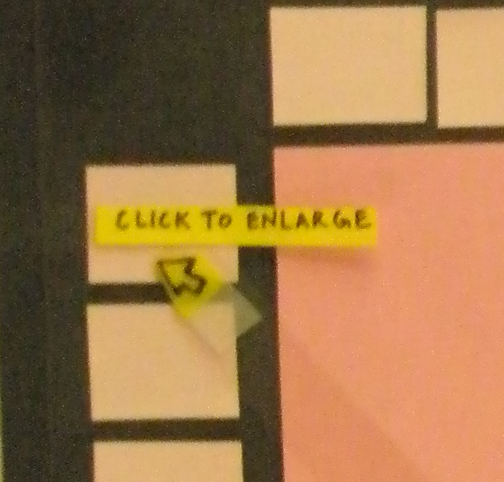

##### Figure 7: Click on smaller videos to enlarge them

## Aesthetic and Minimalist Design

Sport… originally shows just the videos playing. When a user puts the mouse over one, it is then that the buttons to play/pause, add to the playlist, and enlarge and the tooltip become visible. Figure 8(a) and 8(b) show both.

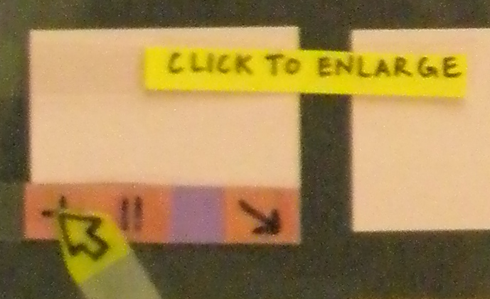

##### Figure 8(a): Plain Video Playing Figure 8(b): When Mouse is over the video

## Help users recognize, diagnose, and recover from errors

The error messages are only needed 1) when a user searches for a video that is not there,2) when a user tries to add a video to the playlist that is already present in the playlist and 3) when the playlist is full and user tries to add videos to it. Sport… takes good care in making the messages precise and understandable, so the users know what they did wrong.

## Help and Documentation

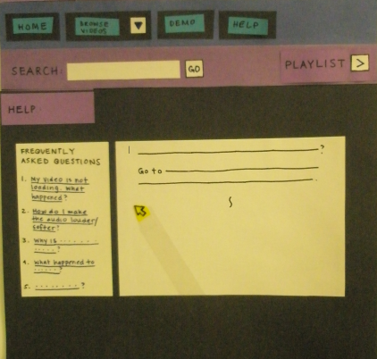Sport… provides extensive help documentation for the users. This help covers all the topics from usage problems, to system troubleshooting. There is this search problem with the menu, as it was mentioned in one of the sections before, which will be fixed in the next section.

Figure 9: Help Screen

## Miscellaneous

Despite it being a great UI, Sport… still has a few problems, that came up during the user evaluation with the other team. One of them was mentioned above. These problems will be briefly stated here and then fixed in the next section.

1. 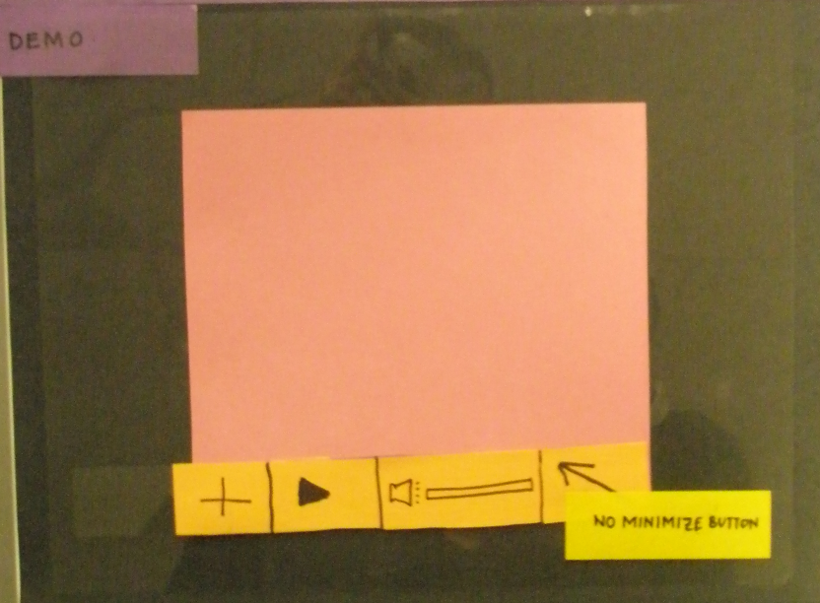Since the demo has only one view (enlarged), there is no need for the minimize button that the other videos have for returning to the normal view.

1. Here I will cover two problems that the users found, first is the navigation confusion. The web browser has its own back button, so we don’t need a separate back button. It’s just confusing, since we have navigation within the search results. Next, the resize/minimize button should have a tooltip to say what it means. Some users may not recognize the button and thus get confused, to by putting that tool tip there can take care of it.

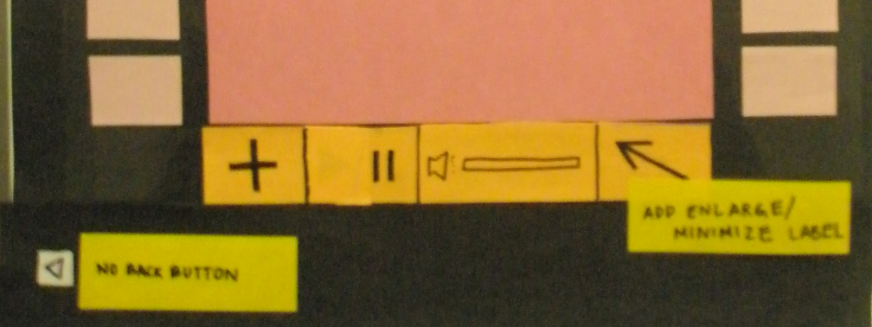

1. Finally, the users sometimes can’t make out what video is being played, so there should be some sort of info that shows up for the video. We will use a tool tip that becomes visible when a mouse moves over a video. It has the info. For the video in it.

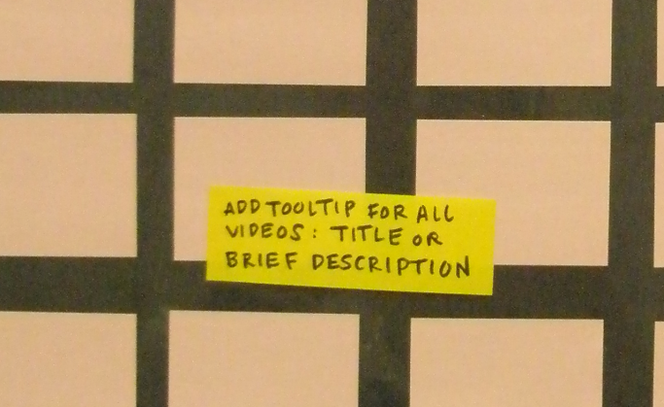

# PART 4

# V. Revision

As listed in the part 3, there were a few problems with the UI. In this section, we will show the changes that Team 1001 made to Sport…’s user interface, to fix those problems. Let’s go over them one by one.

1. The addition of help search capabilities to the interface.

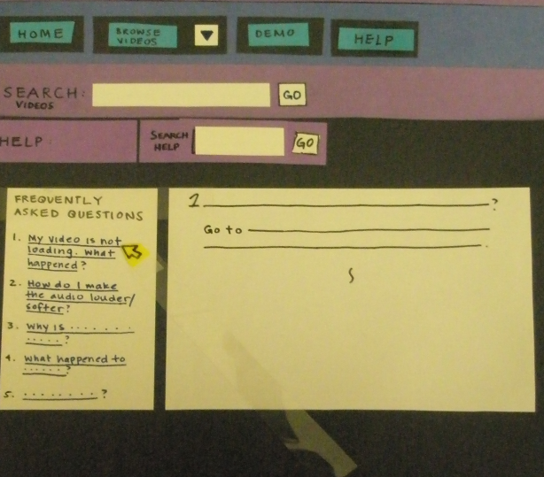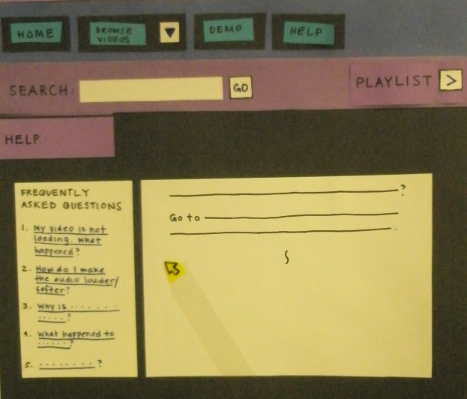

# Before After

1. Remove the minimize button from the demo video

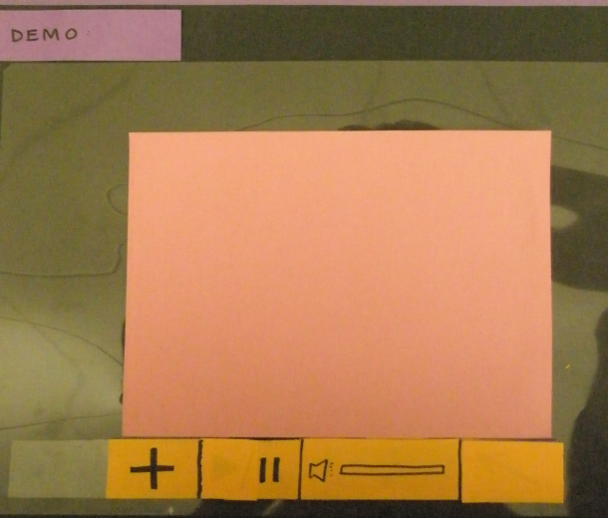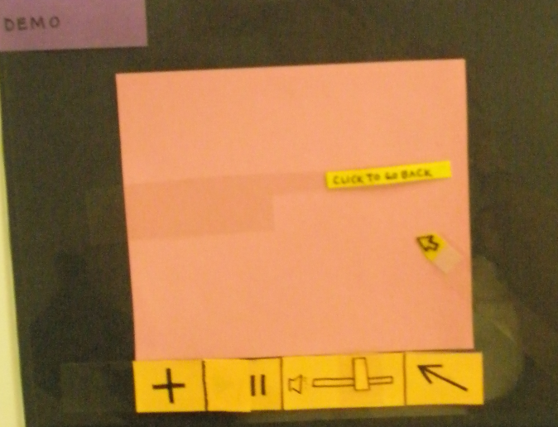

# Before After

1. Information tool tip for the videos on the screen

# 

# Before After

1. 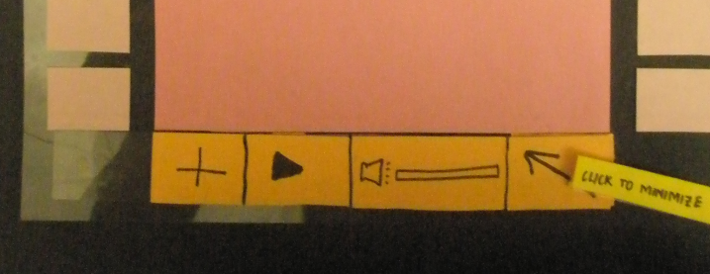Here, we will cover both the tool tip for the minimize button and the removal of the back button at the bottom of the screen.

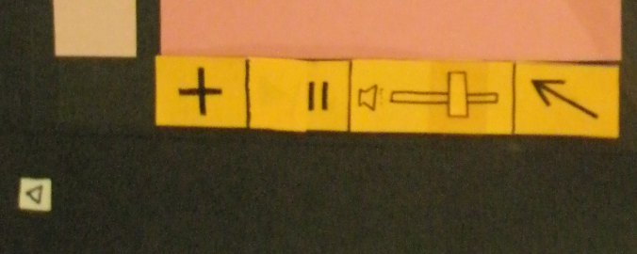

# Before After

This concludes the required changes in the user interface. The above mentioned changes, don’t affect the transition through our use scenarios provided in the Part 1. Following are a couple of snapshots of the team while working on this part.

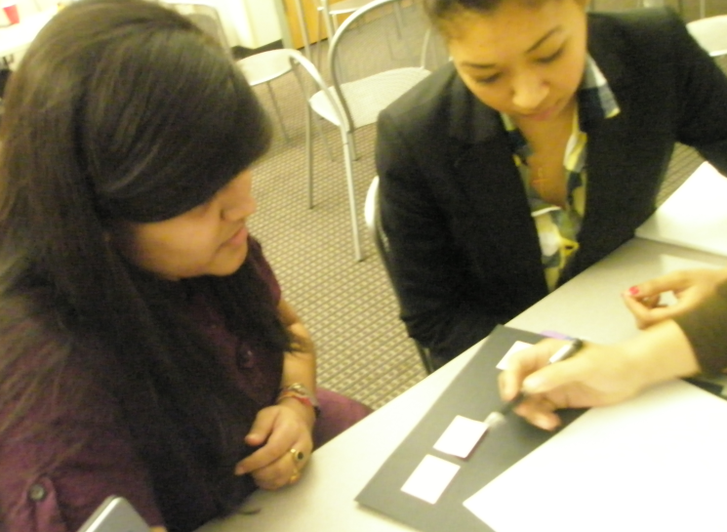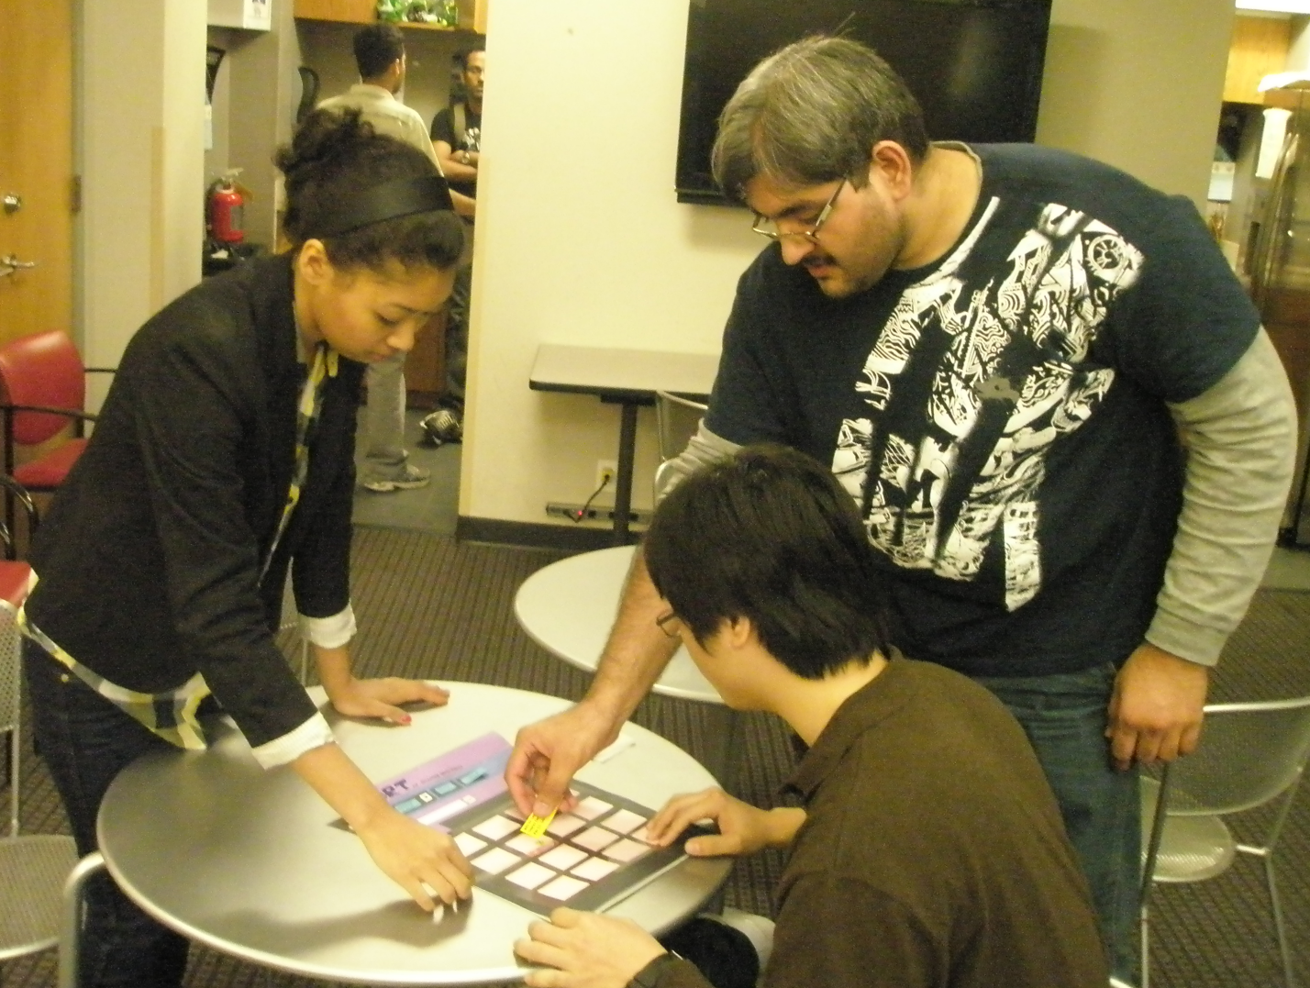

The Revisions change the visual outlook of the screens; however they don’t affect any of the steps originally performed by our personas, in the user scenarios we gave in the part 1. Following are snapshots for the new screens for some of those screens viewed earlier on.

1. Now, when the user moves his/her mouse over a video, they will be able to see some info about it as a tool tip.

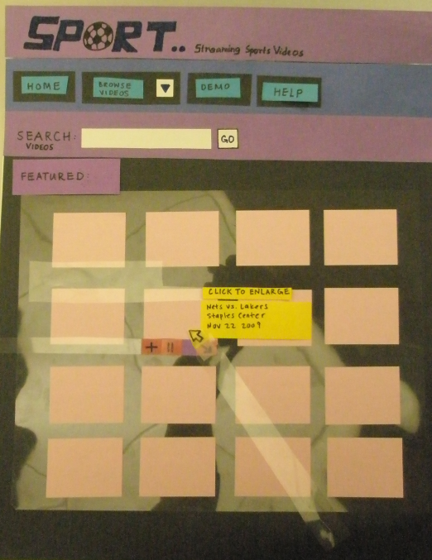

1. Help Screen has its own search box, and to avoid confusion search box’s title says, “search videos”.

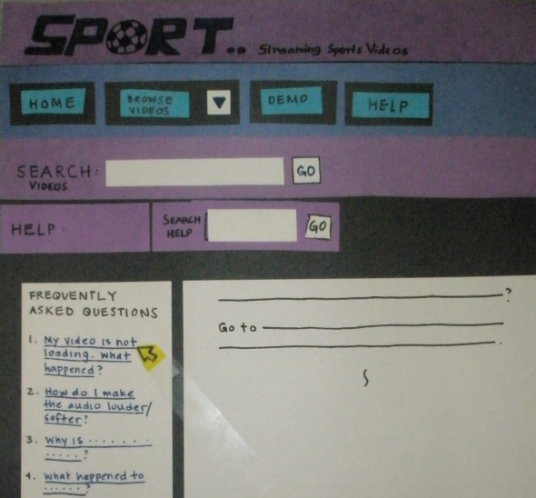

1. Demo Screen’s control bar doesn’t have the minimize button, because there is no need.

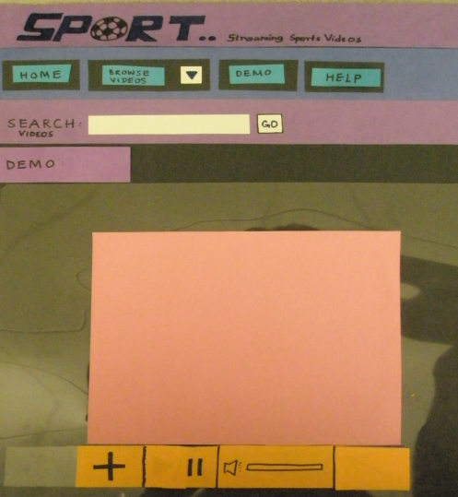

1. 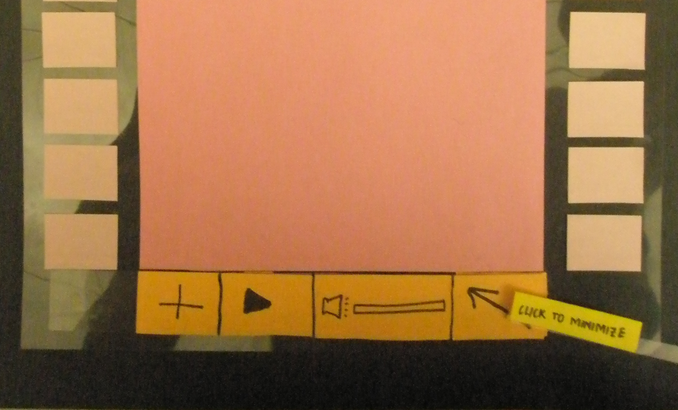There is no need for a back button at the bottom, the browsers support this feature. And also there is a possibility of confusion by having that extra back button. Also there is a tooltip for the minimize button for those who may not know what the button is.

# VI. Conclusion

After all the above steps, we have our UI ready. We can start the implementation process now. The software UI follows all the usability heuristics and is very attractive. It will be a great hit.

## The End.